Tommie Smith

Tommie who was born on June 6, 1944, and was the seventh of twelve children. even though he had pneumonia he was very active he was still very, he was also voted his high school “Most Valuable Athlete”. Now to before the Olympics, in the year of 1966 on May 7, he broke the 200m straight that was beating in 44 years by Tyson Gay. Leading up to the Olympics he wasn’t going to go as a boycott to South Africa and Rhodesia being uninvited, giving back of Muhammad Ali’s world heavyweight title, Avery Brundage to stop being the president of the International Olympic Committee, and adding more African-American assistant coaches. But as this failed they decided to protest, by wearing gloves, protesting poverty by going barefoot, and wearing beads to protest lynching’s, and finally weaking buttons saying OPHR. After, he won with a time of 19.83 he protest by rising his right in a black glove, wearing black socks with no shoes, to represent African-American poverty in the United States, with John Carlos who got second place. Because of this both we’re suspended from the U.S., and threaten with being expelled from the games.

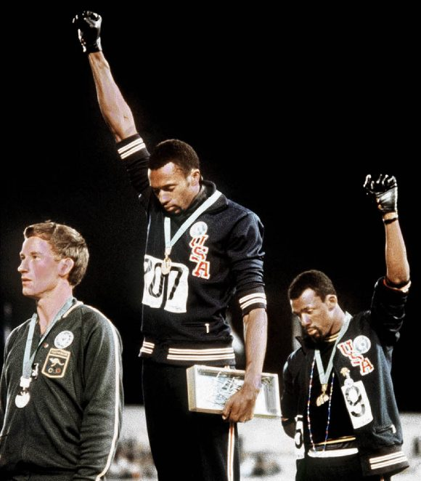

[This Photo](http://gabriellagiudici.it/tag/tommy-smith-e-john-carlos/) by Unknown Author is licensed under [CC BY-SA-NC](https://creativecommons.org/licenses/by-nc-sa/3.0/)